Lab Report

Date: May 15th , 2026
Team: E1
Team Members
Last name | First name | Email
Rahman | Md Mahbubur | md-mahbubur.rahman@stud.hshl.de
Sakib | Md Naimur Rahaman | md-naimur-rahaman.sakib@stud.hshl.de
Xu | Yongyu | yongyu.xu@stud.hshl.de
Koluacik | Baris | baris.koluacik@stud.hshl.de

Goal
Assemble the vehicle and test the sensors to ensure they are functioning properly.
Discussion
- The motor is being pushed by a screw, but this has little effect, as shown in Figure 1.
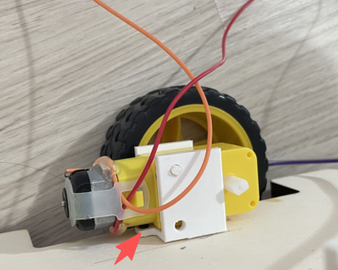
Figure 1 The Motor Holder

- The IR-Sensor Holders were not sturdy enough and broke during installation, it has been reprinted.
- The chassis is too close to the ground, but no issues have been observed so far, as shown in Figure 2.

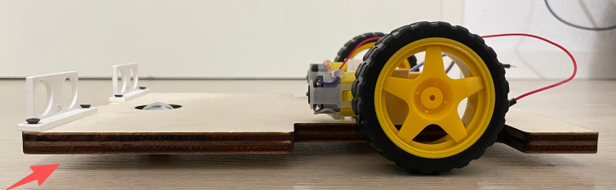

Figure 2 The chassis and ground

- Both the IR-Sensors and the Ultrasonic-Sensors are functioning properly, please refer to the videos in the folder for details.

